**SE 102.3 – Web Based Application Development**

**Tutorial**

1. Write down the HTML codes required to generate the following outputs.

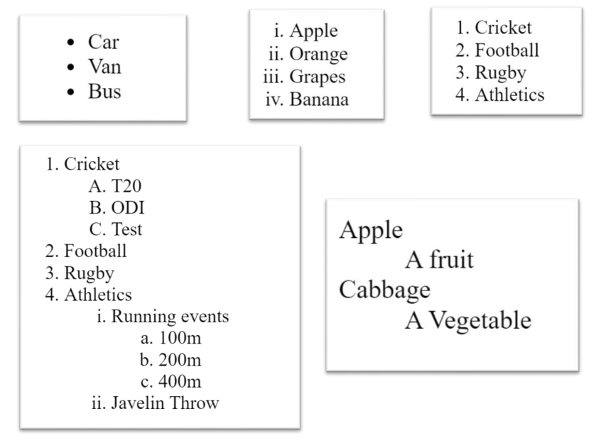

<html>

<head><title>HTML TAGS </title>

</head>

<body>

<ul type="squere">

<li>Car</li>

<li>Van</li>

<li>Bus</li>

</ul>

</body> </html>

<html>

<head><title>HTML TAGS </title>

</head>

<body>

<ol type="i">

<li>Apple</li>

<li>Orange</li>

<li>Grapes</li>

<li>Banana</li>

</ol>

</body> </html>

<html>

<head><title>HTML TAGS </title>

</head>

<body>

<ol type="1">

<li>Cricket</li>

<li>Rugby</li>

<li><football</li>

<li>Athletic</li>

</ol>

</body> </html>

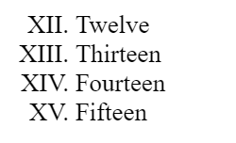

<html>

<head><title>HTML TAGS </title>

</head>

<body>

<ol type="I" start ="XII">

<li>Twelve</li>

<li>Thirteen</li>

<li>Fourteen</li>

<li>Fifteen</li>

</ol>

</body> </html>

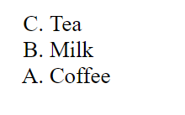

<html>

<head><title>HTML TAGS </title>

</head>

<body>

<ol type="A" start ="C">

<li>Tea</li>

<li>Milk</li>

<li>Coffe</li>

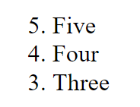</ol> </body> </html>

<html>

<head><title>HTML TAGS </title>

</head>

<body>

<ol type="1" start ="5">

<li>Five</li>

<li>Four</li>

<li>Three</li>

</ol>

</body> </html>



<html>

<head><title>HTML TAGS </title>

</head>

<body>

<dl><dt>Apple</dt>

<dd>A fruit</dd>

<dt>Cabbage</dt>

<dd>A Vegetable</dd>

</dt>

</body> </html>

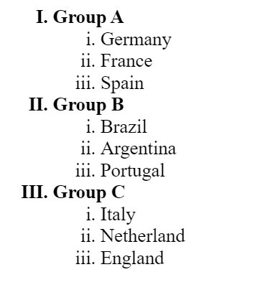

<html>

<head><title>HTML TAGS </title>

</head>

<body>

<ol type="I">

<li>Group A</li>

<ol type="i">

<li>Germany</li>

<li>France</li>

<li>spain</li></ol>

<li>Group B</li>

<ol type="i">

<li>Brazil</li>

<li>Argentina</li>

<li>Portugal</li>

</ol>

<li>Group C</li>

<ol type="i">

<li>Italy</li>

<li>Netherland</li>

<li>England</li>

</ol>

</ol>

</body> </html>

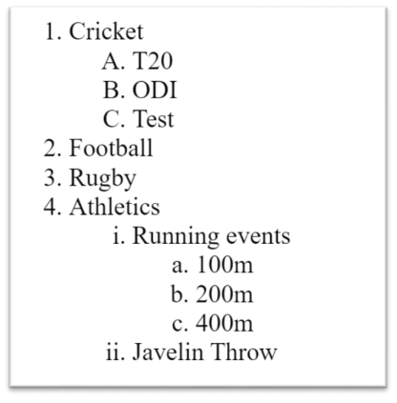

<html>

<head><title>HTML TAGS </title>

</head>

<body>

<ol type="1">

<li>cricket</li>

<ol type="A">

<li>T20</li>

<li>ODI</li>

<li>Test</li></ol>

<li>Football</li>

<li>Rugby</li>

<li>Athletics

<ol type="i">

<li>Running events</li>

<ol type="a">

<li>100m</li>

<li>200m</li>

<li>400m</li>

</ol>

<li>Javelin Throw</li>

</ol>

</ol>

</body> </html>